INSTRUCTIONS FOR SALIVA COLLECTION USING THE SALIVETTE SALIVA COLLECTION KIT
- Saliva collection to screen for Cushing’s syndrome is recommended between 11:00 pm and midnight, or at the direction of your medical provider.
- Do not eat, drink, smoke, or use oral hygiene products for at least 60 minutes before you start the collection process.
- Rinse the mouth with water and discard. Please wait at least 10 minutes after this rinse to start the collection procedure.
- During this time, review the detailed instructions for the SALIVETTE Saliva Collection Kit below.

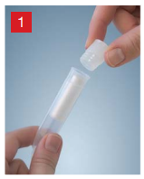
- Uncap the tube.

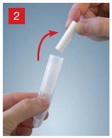
- Remove the swab from the Salivette.

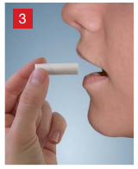
- Place the swab in the mouth (e.g. in your check) where it should remain for 2 minutes. Do not chew on the swab.

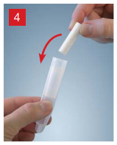
- Return the swab with the absorbed saliva to the Salivette.

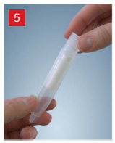
- Replace the stopper in the top of the tube.

- Label the sample with the appropriate patient information (patient full name, patient DOB) and store in the refrigerator until returned to the lab.

