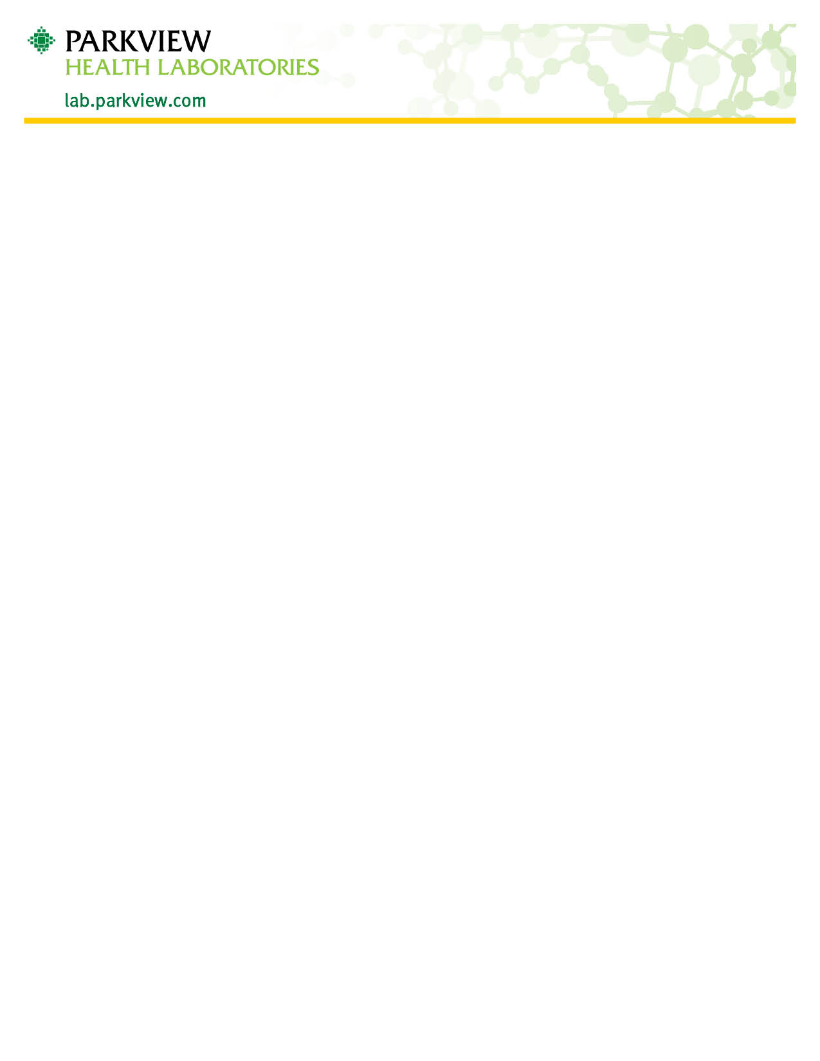
‘

Rotavirus Stool Collection
- Stool specimen should be collected in a disposable clean container, without preservatives or detergents
- Wash hands after collection
- Specimen should be labeled with full legal patient name, date of birth, date and time of collection
- The specimen should be brought to the laboratory as soon as possible for testing or refrigerated no longer than 72 hours.
For Pediatric Patients:
- The stool may be collected from a diaper
  - Formed stool can be scooped into a clean container with a sterile swab or wooden stick.
  - Liquid stool can be collected by lining the diaper with plastic wrap. Place plastic wrap with stool specimen into the clean container
Any questions concerning collection for Rotavirus may be directed to Parkview Health Laboratory at (260) 266-1500 Option 1.

