‘

Pinworm Paddle Collections
The accuracy of this test depends upon your accuracy in collecting the timely specimen.

- Collect the specimen when the patient first awakens (preferably when it is still dark outside) and prior to the patients urinating or bathing.
- Pull the pinworm swube paddle device apart.
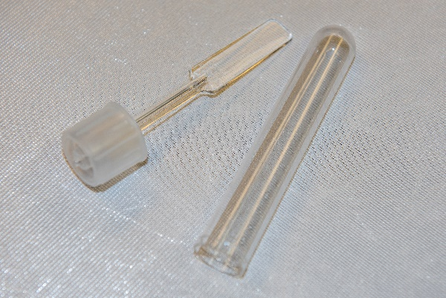
  - Note that one side of the paddle is labeled “sticky side”
  - Do not to touch this “sticky side” of the paddle with your fingers.
- Using a rocking motion, press the sticky side of the paddle collection device across the anal area.
- Put the device back together; again being careful not to touch the sticky collection area of the paddle with your fingers.
- Wash hands after collection.
- Specimen should be labeled with full legal patient name, date of birth, date and time of collection.
- Bring the specimen to the laboratory at your earliest convenience. This specimen is stable for 72 hours.

This test is based on the fact that the pinworms migrate out at night and lay their eggs around the anal area. Usually only the eggs are recovered via this method. Positive identification of pinworm is possible less than 15% of the time on fecal specimens. Therefore, the pinworm swube paddle device is the specific test for the recovery of pinworm.

