CT/NG on the Roche Cobas 6800 – Specimen Collection guide – Clinician Collected Anorectal (Rectal) Swab

WARNING: Do not pre-wet swab in cobas PCR media before collection

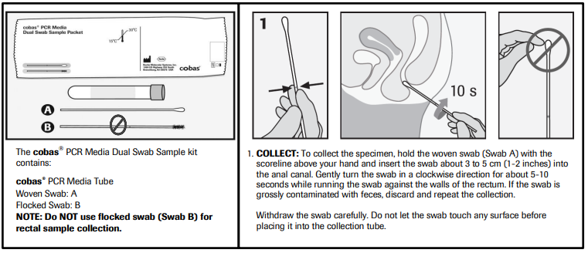
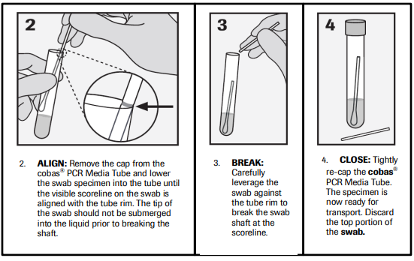

Following specimen collection, transport and store the cobas® PCR Media Tube containing the collection swab at 2°C to 30°C.

